Data Analytics Project #2 Proposal:

Lynn Eitelman

Irene Eshun

Yuba Sigdel

Topic and Rationale: Weather Changes over time… In the United States

Link to data set(s): <https://www.ncdc.noaa.gov/cdo-web/datasets>

Screenshot of the metadata: <https://www7.ncdc.noaa.gov/CDO/CDODivisionalSelect.jsp#>

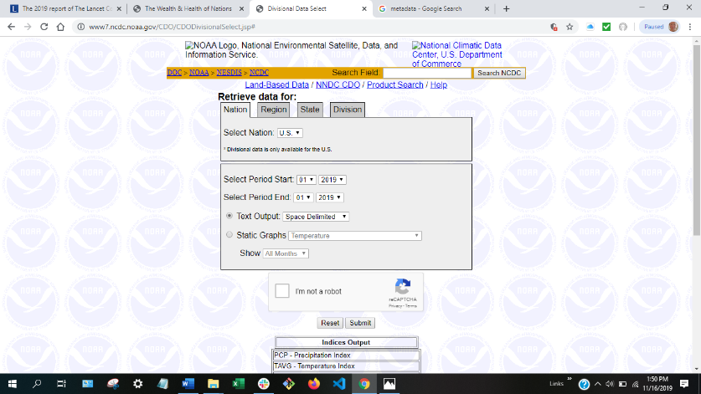

Screenshots of relevant visualizations:

1. Motion chart

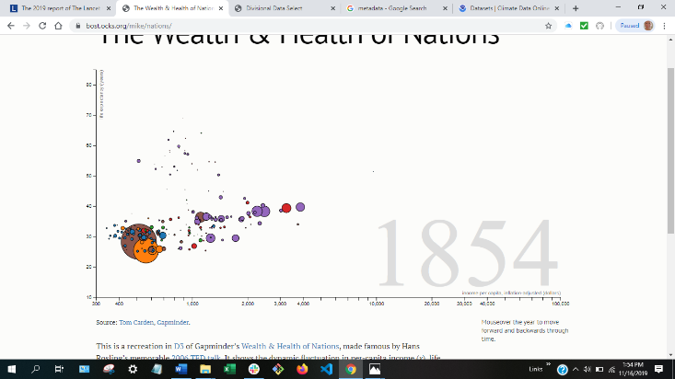

1. Scatter plot

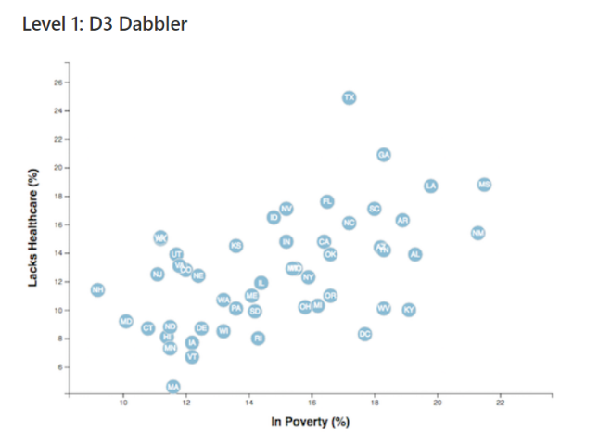

1. Heat map

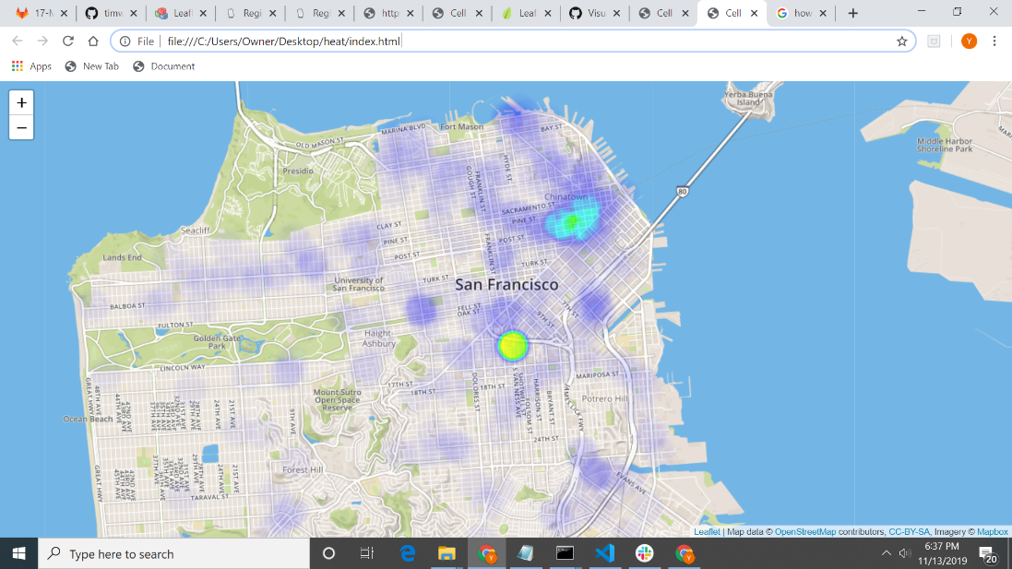

Sketch of final design:

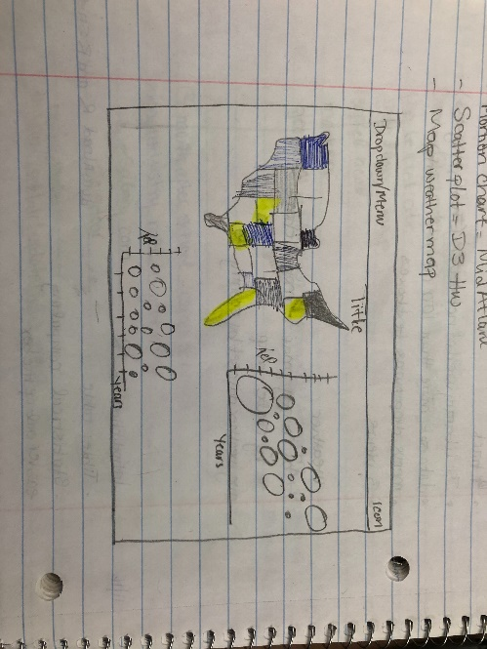

Link to primary GitHub repo: <https://github.com/eshuni/climatechange>